Eulogy to Doris Orme ~ William Haines (UTS’92)
By William S.H. Haines|Published: May 19, 2016

Thursday May 19
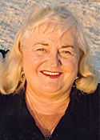Today I was blessed to officiate at the service to celebrate the life and entry into heaven of Doris Orme, the first person in the Western world to accept the Principle. This was the eulogy:
Doris Barbara Walder was born in New Jersey 8th January 1930. Her parents were Frederick and Hedwig Walder. Her father was a descendant of Frederick, the last Kaiser of Germany, and thus of Queen Victoria. She had a sister Norma and a brother Freddy.
Doris married and moved with her husband to Oregon where she had two children Lori and Terry.
In 1959 she met Miss Young Oon Kim, a Korean missionary sent to the United States by Sun Myung Moon. Doris became the first follower of Sun Myung Moon in the Western world. With two other women, (Pauline Verheyen and Patty Pumphrey) she joined a group to study the Principle with Miss Kim. They were all caught up in the spirit and decided to become missionaries for God and moved with Miss Kim to San Francisco. They called themselves the Unified Family and established a network of centers and a pattern of living and activities that came to spread throughout the United States and later Europe.
In 1960, the small Unified Family celebrated the Marriage Supper of the Lamb and shared a piece of the cake that was brought from the event in Korea. At this celebration, they were very high in the spirit. Miss Kim came to call Doris “God’s Fireball’ because she was always on fire for God witnessing and bringing people to the Lord. Doris and Pauline worked as waitresses in restaurants and witnessed to their customers such as the district attorney general and chief of police.
Doris later moved to Los Angeles where there was a center in Inglewood. There Doris witnessed to Zed Robinson – an entertainer who sold everything, joined, and funded Sun Myung Moon’s 1965 world tour to establish holy grounds. She also witnessed to Teddy Verheyen who became the missionary to Holland and Ursula Schumann, a very attractive and well educated German girl. Ursula herself witnessed to other Germans such as Peter Koch and Paul Werner. Paul, Peter and Ursula went to Europe as missionaries to Austria, Germany and Spain respectively, making Doris the ancestor of the European movement. Doris continued to pioneer many cities and states in America bringing many people into the Unified Family.
In 1965, Doris had a revelation of being in Italy with the Pope. Miss Kim reported this to Father Moon who sent her to Italy. She set out in faith with just a suitcase and $100, but no idea where she would stay. On the plane, she sat next to a little old lady who invited her to stay with her in Rome. She introduced Doris to an Italian priest, Pastor Nua, who would say to Doris. ‘I am small potatoes; you are big potatoes’. One day the priest saw Doris praying in front of Vatican and told her. “I’ve got a ticket to sit with the Pope.” He gave it to her and so she went to sit with the Pope. The Pope wanted to start an ecumenical movement and in 1960 appointed a priest from New Jersey, Father Thomas Stransky, to be one of the founding members of the Secretariat for the Promotion of Christian Unity. The lady Doris was staying with introduced her to Father Stransky and so Doris came to assist him in the development of the ecumenical movement.
In Rome Doris witnessed to Barbara Burrows, later van Praag, who became a very successful missionary in her own right. The Unified Family in Rome expanded and an Englishman, Martin Porter, who was a descendant of Edward the Confessor joined. He later became the national leader of Italy. He was blessed to Dawn Faroni whose father was a wealthy doctor who owned several hospitals in Rome. Doris had healed Dawn by teaching her the Principle. Her father went on to protect Doris from political opponents by testifying that she was a woman of God.
In 1967, Doris went to Amsterdam where she stayed with Teddy Verheyen on his canal boat. While she was there she became very sick and was taken care of by the Vanderstock family in Laren. She recovered and the family was so impressed by her that they all joined. This family contributed hugely to the development of God’s work in several countries.
The following year Doris came to the UK. She had previously sent June Darby and Patricia Hartmann to England from Italy to start the movement. As the senior member, Doris took over leadership of the Family. Doris was invited to Findhorn by Anthony Brooke, the Rajah Muda of Sarawak, who she had met in California. Brooke was taken by Miss Kim to meet Father Moon in Korea where he testified that he was the messiah. Brooke later became very well known for his work for peace and spirituality. In Findhorn, Doris taught three chapters of the Divine Principle and Dennis who was living there at the time received a revelation it was true as well as a revelation of Father Moon. Dennis left Findhorn and followed Doris to London. He moved into the centre in the Old Brompton Road where he joined June Darby, Patricia Hartmann and her sister, Alec Herzer, Ian Alexander, Christopher Vipond Davies and others.
In 1969, Doris was blessed to Dennis and they remained devoted to each other for the rest of their lives. In 1970, Doris was very happy to give birth to Young Oon (Donna), the first blessed child in the western world who she loved very much.
Over the following eight years, they worked hard together with other members to revitalise and evangelise the nation. Doris brought forth a movement that was very inspired and filled with revelations and amazing activity. During these fruitful years, many capable members joined and all the properties that form the basis of the movement in the UK until this day were acquired.
Doris was a great crusade leader. Her teams travelled around Britain and Europe witnessing and doubling in size as they went. She was a wonderful singer and spirit filled preacher. The Unified Family singers entered the Reading Festival held to celebrate the 1100th anniversary of the city and were a huge success.
In April 1978, the control of the UK movement passed into the hands of Father Moon and subsequently a series of Korean and Japanese leaders. Doris and Dennis moved to Germany where they successfully led the One World Crusade in the north region for three years.
After that, they moved to the United States where amongst other things they were Itinerant Workers and church leaders in Washington and California. In Washington, Doris reached out to black churches where she sang gospel songs and won the respect of the black community. Dennis and Doris were both awarded honorary doctorates from Howard University, which is the most respected black university in the United States, for their work in underprivileged communities and for their stand for the rights of African Americans to be treated equally.
In 1993, Doris received a revelation that they were now living in the direct dominion of God and were free to pursue their own spirituality without restriction for the golden age that is to come. Over the next few years, Doris received a series of revelations which were published in a book (below).
In recent years, the Ormes took a firm stand against the invasion of Iraq and strongly supported peace and the end of violence. Living in a staunchly Republican area they bravely spoke in support of Obama and Doris was very happy when he was elected the first black president of the United States. In summary, Doris was an extraordinary person who loved God passionately and fought for the souls of nations and continents.
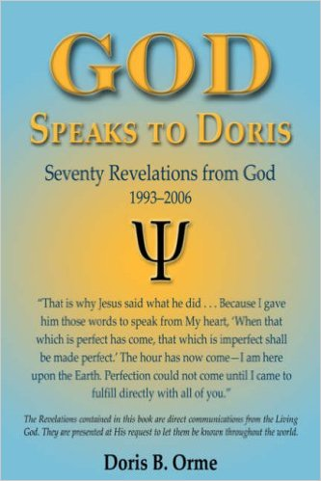
God Speaks to Doris
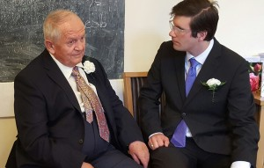
Dennis Orme with current FFWPU-UK National Director, Matthew Huish
See more at:
http://www.utsalumni.org/news/eulogy-to-doris-orme-william-haines-uts92-17368/#sthash.m6ciyHS9.DlJofmsL.dpuf

