**My Experience of Winter Witnessing in Albania**

***I would like to recommend other elder members in Europe to consider a trip to Albanian to give and receive life and love in this Vision 2020 Strategic nation***

By Mr. Bengt de Paulis a Swede living with his Blessed Family in Finland

In the spring of 2013, the National Leader of Finland, Mr. Yoshizumi, and I discussed  
what to do to get results in church activities. He also knew my desire for life in a warmer climate. ☺ He suggested I go to Albania to have the experience of that European country chosen as a strategic nation by True Parents for Vision 2020.

I was welcomed by Mr Gani Rroshi and his wife Marjeta on arrival after a 15 hour bus journey from Athens (a cheaper way to get there!).

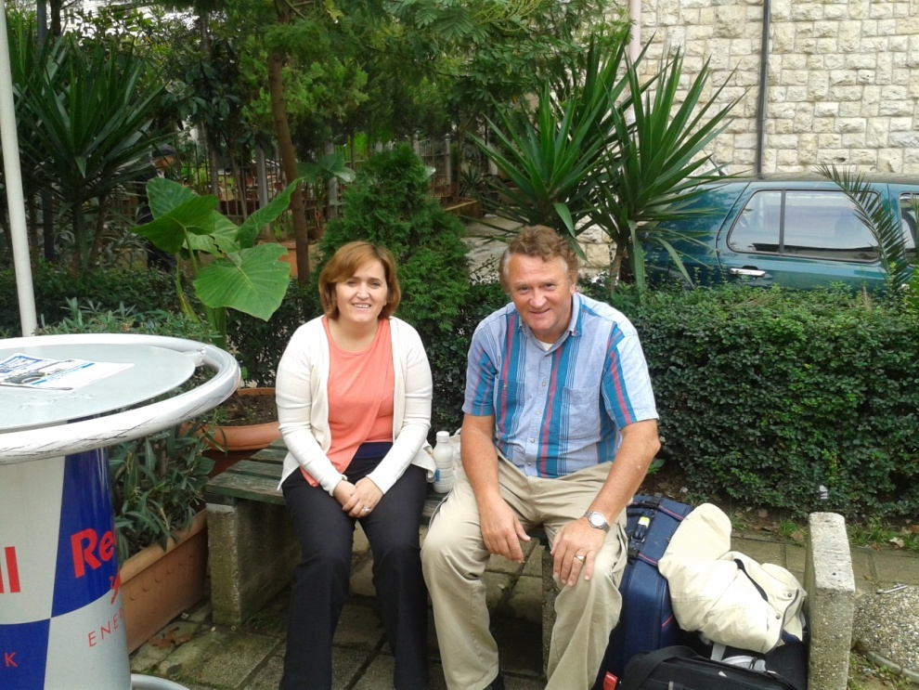  
 They suggested I go to the nearby city of Elbasan, where Ajet and Greta recently started as center leaders. Travelling between cities in Albania is made with minibuses (called furgons"). When the minibus is full of people, normally around 10 people off you go. The City of Elbasan.

Arriving in Elbasan, I was welcomed by Ajet and sister Dajana. The center was about 10 min walk away. The weekly schedule was, 6am Hoon Dok Hae, then exercise, breakfast and lectures if guests were coming, or internal guidance by an older member Mr Arben. Witnessing normally in the afternoon after lunch. Evening meal around 8pm. Then lecture practicing and end of Day Prayer session.

I had some good results, even I don’t speak many words in Albanian. Some spoke English, most not at all or not so good. With a few Albanian phrases learnt, and by handing their telephone number to center leader Ajet, I could encourage them to call him and find out more.

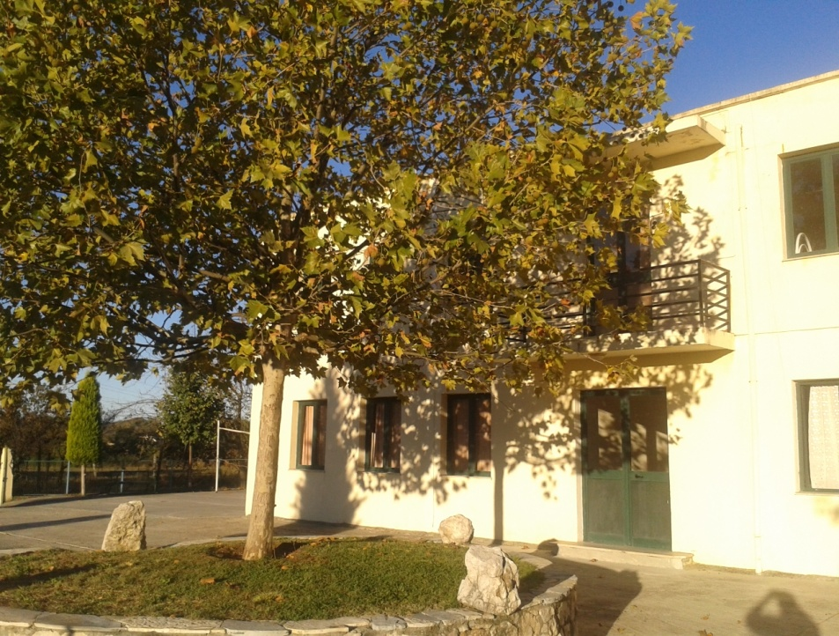  
Some guests I was able to lead directly to the center door, where they were introduced to DP by Greta or one of the other sisters. One man, a strong Christian prayed in the morning to meet someone to witness about Jesus to, so later in the day he met me on the street. ☺

I introduced myself and invited him to the center. Some days later I was for the 2nd time approached by him on the street, and then I felt I really had to act on the moment, and led him to the center. He continued to come daily for several weeks, and agreed to go to the Jan. WS in Mullet. Success for me and our center members. ☺

I had many other exciting experiences, for example together with UPF in Elbasan we planted trees in a park. The City Mayor was there and Albanian National News TV covered the event.  
